Biographies and photos of Authors of the Article:

**Morphological Filter Detector for Image Forensics Applications**

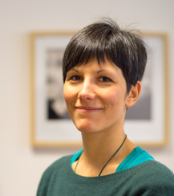GIULIA BOATO is Associate Professor at the Department of Information Engineering and Computer Science (DISI) of the University of Trento (Italy). She is Associate Editor of the IEEE Transactions on Image Processing, the ELSEVIER Signal Processing: Image Communication. Her research interests are focused on image and signal processing, with particular attention to multimedia data security and digital image and video forensics, but also intelligent multidimensional data management and analysis. She is author of 120 papers in international conferences and journals, with H-index 22 (Google Scholar). She is elected member of the IEEE Multimedia Signal Processing Technical Committee (MMSP TC), the IEEE Information Forensics and Security Technical Committee (IFS TC) and the EURASIP Special Area Teams Biometrics, Data Forensics, and Security.

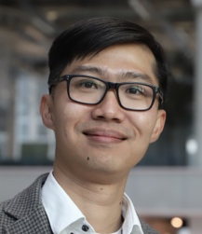DUC-TIEN DANG-NGUYEN is currently an Associate Professor at the Department of Information Science and Media Studies (Infomedia), University of Bergen (Norway). His main area of expertise is on multimedia forensics, lifelogging, multimedia retrieval, and computer vision. He is author of 90 papers in international conferences and journals, with H-index 18 (Google Scholar, December 2019). He is member of IEEE Signal Processing, ACM, SIGIR, IAPR and INSTICC. He has organized and chaired over 20 workshops and special sessions, has been served as program committee for numerous international conferences and workshops, and has peer-reviewed for many top journals and conferences in the fields of lifelogging, multimedia forensics, and pattern recognition.

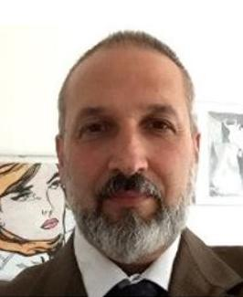FRANCESCO G.B. DE NATALE was the Head of the Department of Information Engineering and Computer Science (DISI), University of Trento (Italy) from 2007 to 2010, where he currently leads the MMLab Research Laboratory. He is also a Professor of telecommunications with the University of Trento. His research interests include multimedia communications, where he published over 200 works in the major international journals and conferences. He is also a member of the Board of Governors of the CNIT Consortium. He has been an Associate Editor of the IEEE Transactions on Multimedia and the IEEE Transactions on Circuits and System for Video Technologies, and currently associate editor of IEEE Transaction on Image Processing.